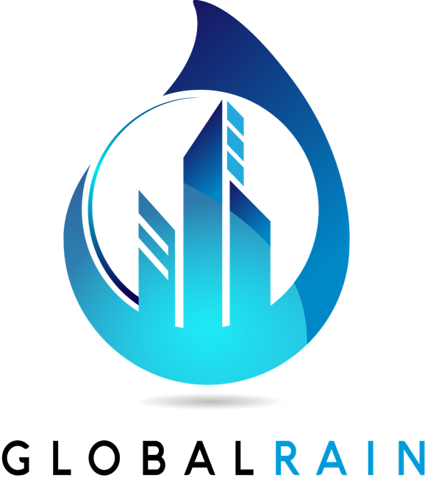

Practices for Secure Software Report

Table of Contents
Document Revision History 3
Client 3
Instructions 3
Developer 4
1. Algorithm Cipher 4
2. Certificate Generation 4
3. Deploy Cipher 4
4. Secure Communications 4
5. Secondary Testing 4
6. Functional Testing 4
7. Summary 4
8. Industry Standard Best Practices 4

Document Revision History

Version | Date | Author | Comments
1.0 | 10/17/24 | Zachariah Spencer | 1st Complete Draft

Client



Developer
Zachariah Spencer

Algorithm Cipher
For encryption in Artemis Financial's software, I recommend using the AES (Advanced Encryption Standard) cipher.

- Overview: AES is a symmetric encryption cipher, meaning it uses the same key for both encryption and decryption.
- Hash Functions and Bit Levels: AES operates with key sizes of 128, 192, or 256 bits, with a 256-bit key offering strong security.
- Random Numbers and Key Management: Keys and Initialization Vectors (IVs) are generated using random numbers, ensuring unique encryption each time. It's important to securely manage symmetric keys, often requiring secure key exchange protocols when transmitting keys over a network.
- History and Current State: Since replacing the older DES (Data Encryption Standard), AES has been widely adopted and remains resistant to cryptanalysis, making it well-suited for government and financial industry security standards.

Certificate Generation
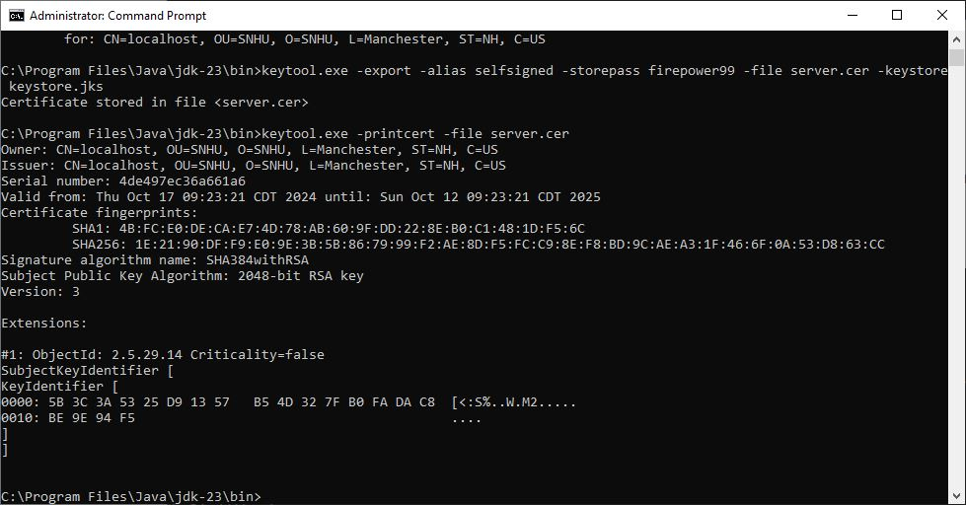

Deploy Cipher
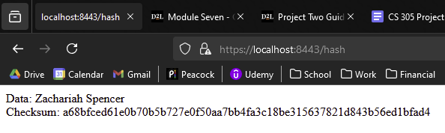

Secure Communications
Firefox shows a small notification to the left of the URL stating the connection is encrypted but not secure. This is because the certificate used to verify the site is self-signed for testing purposes and the deployed site will have a properly registered certificate.

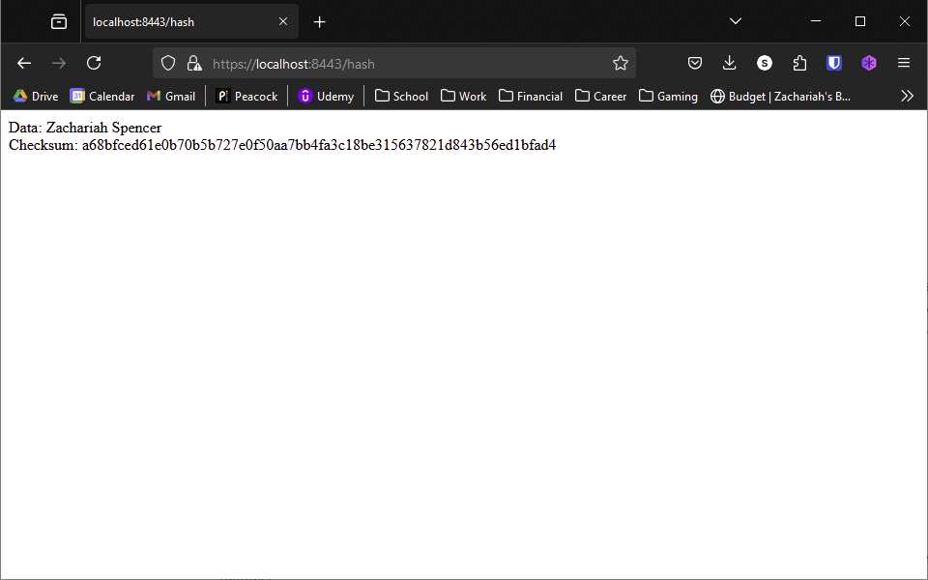

Secondary Testing
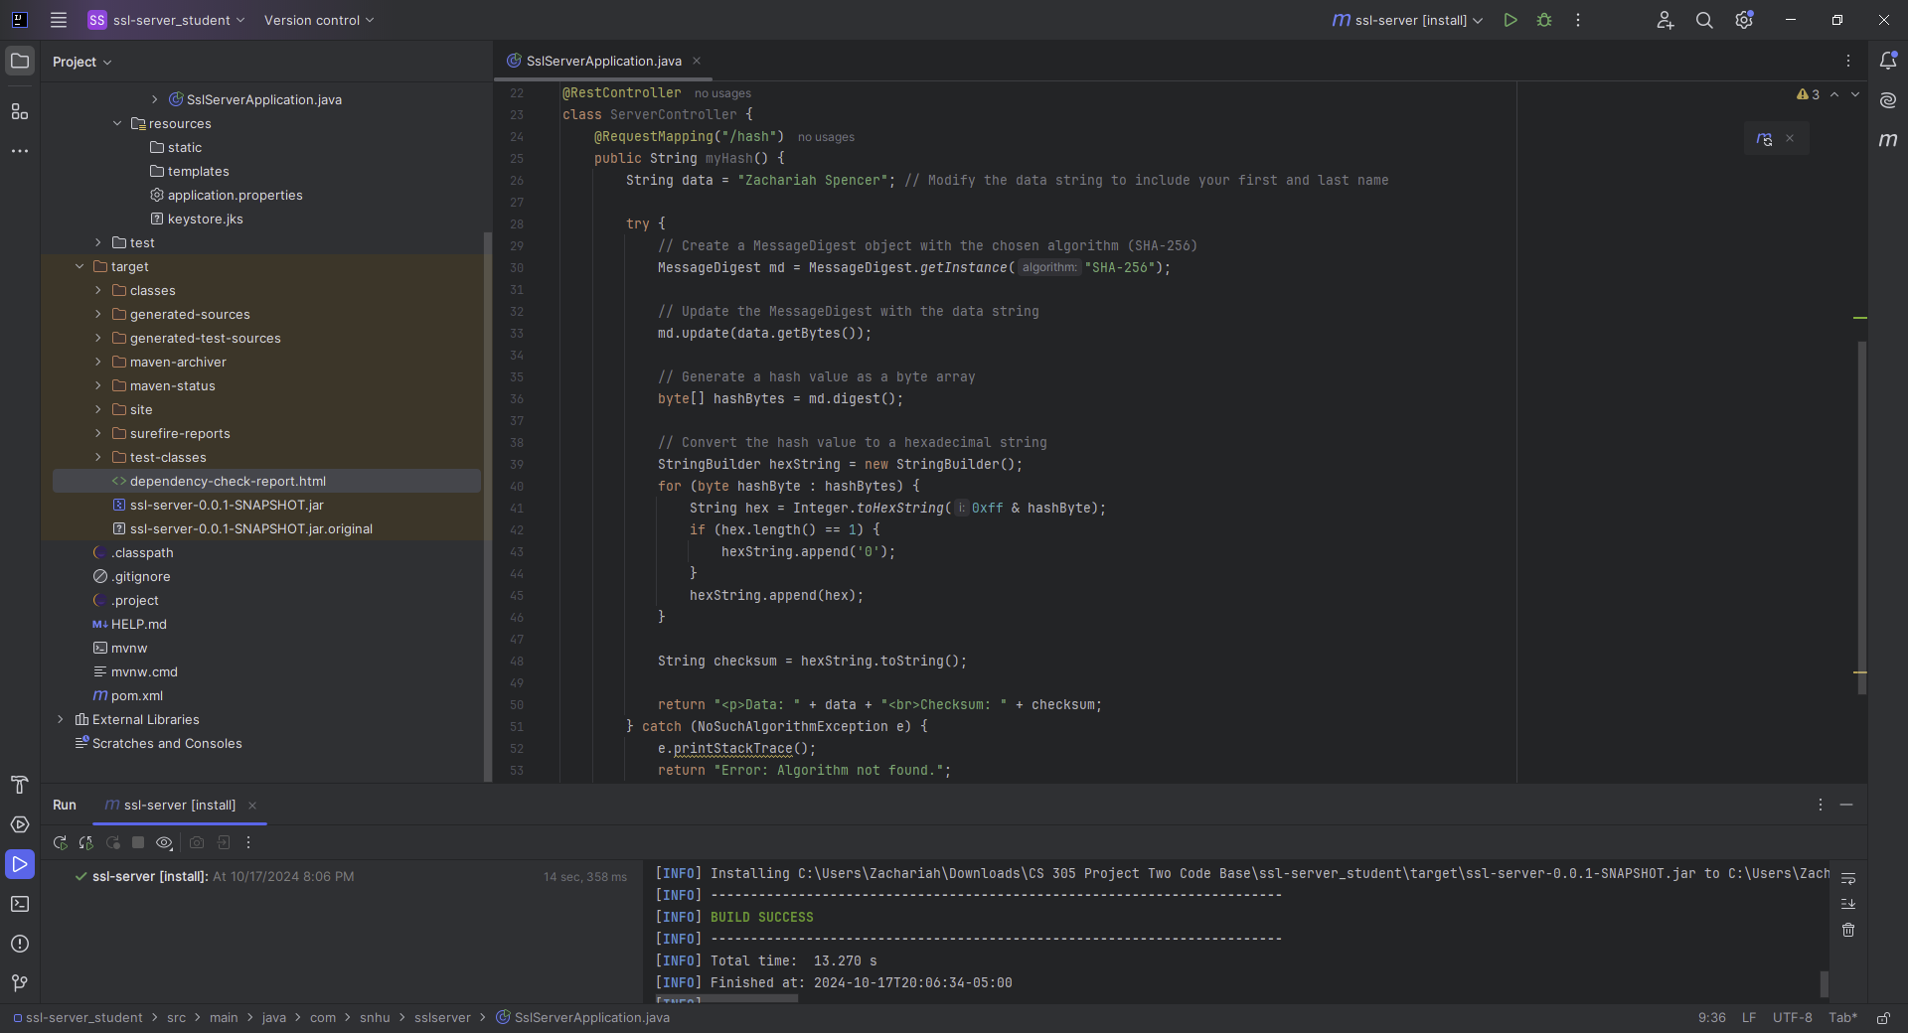
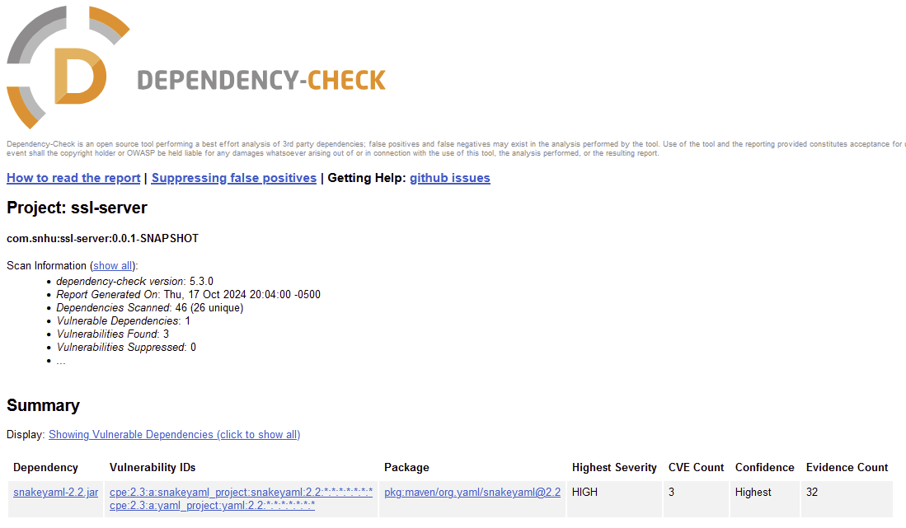

Functional Testing

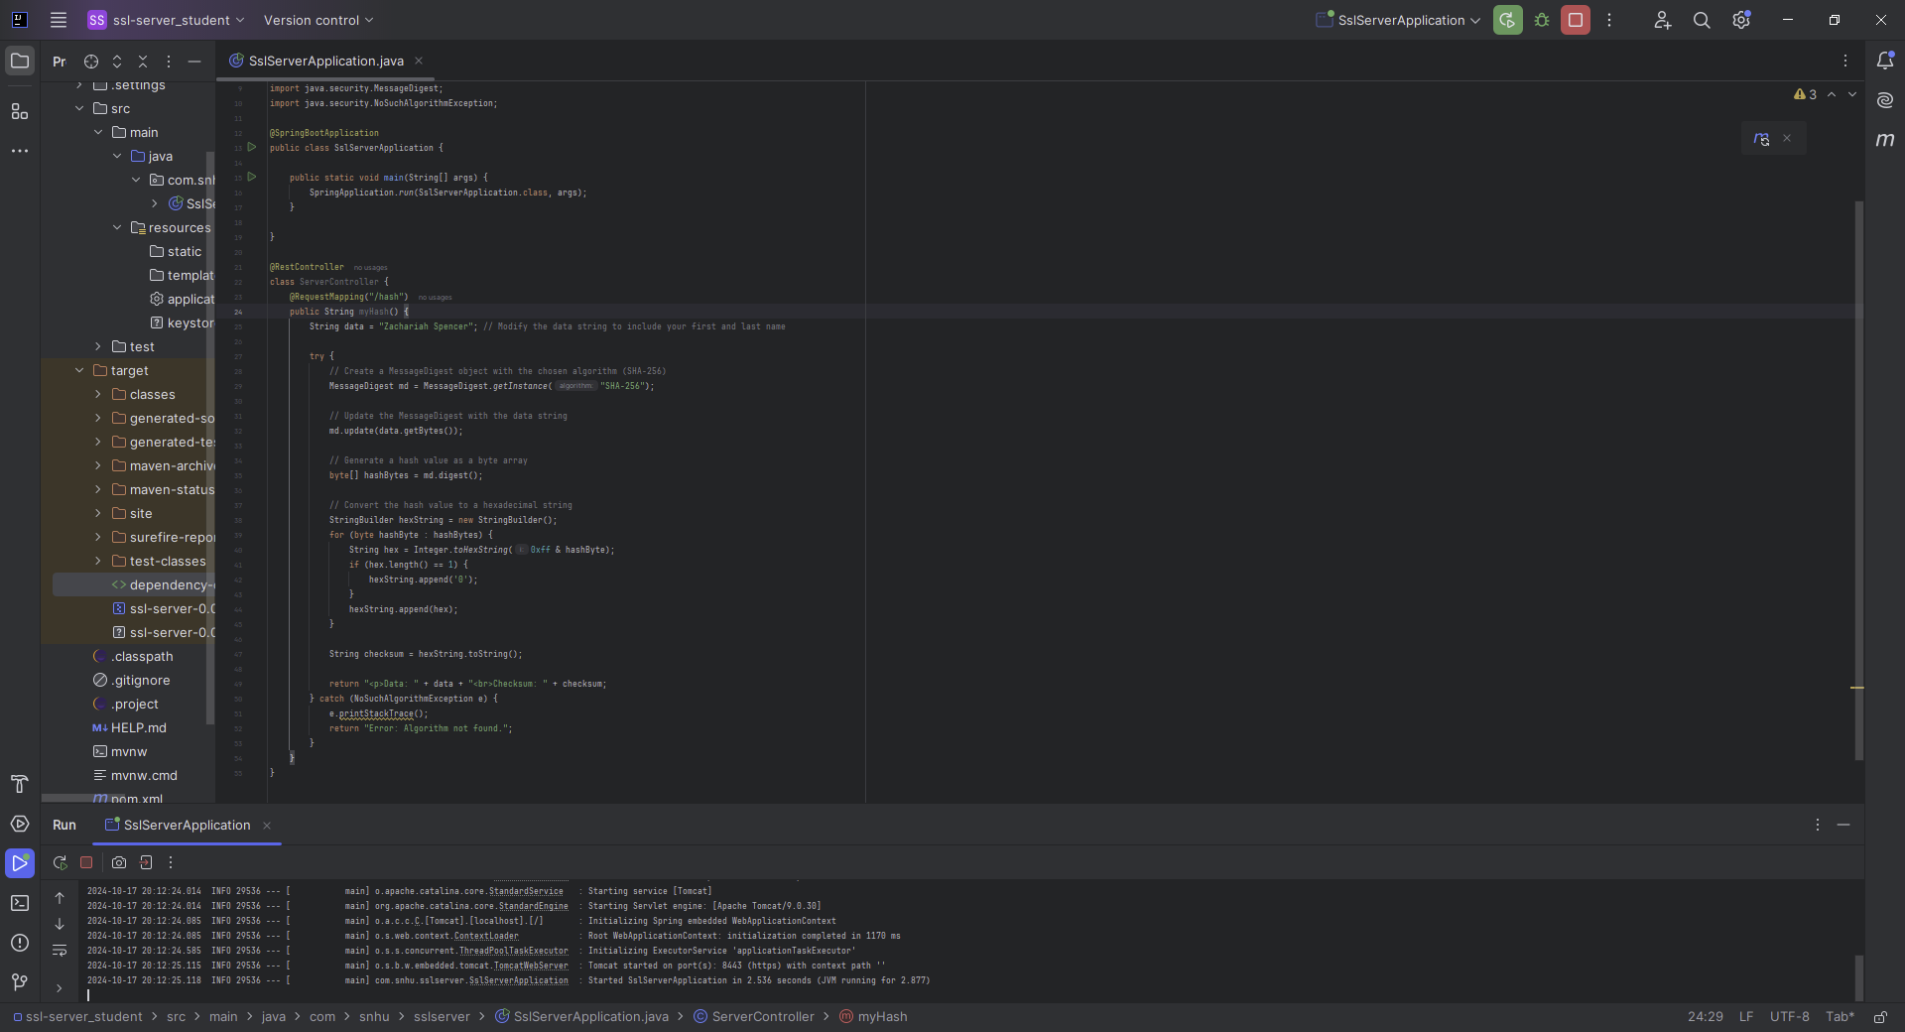

Summary

I made several updates to the codebase, including adding AES encryption to protect sensitive data and improving certificate management for secure communication between services. By reviewing the Process Flow Diagram, I identified vulnerable areas and strengthened security at key points. I also added extra security layers, such as data encryption, secure communication using HTTPS, and proper certificate management for authentication and integrity.

These changes help protect Artemis Financial from data breaches, ensuring customer information stays safe. This boosts customer trust, improves the company’s reputation, and keeps it compliant with industry security standards.

Industry Standard Best Practices

To keep software secure, I suggest following these best practices:

1. Regular Updates and Patching: Keep all software, libraries, and dependencies up to date. Apply patches as soon as vulnerabilities are identified to prevent attacks.

2. Secure Coding: Follow secure coding guidelines, such as validating inputs, managing memory safely, and avoiding common vulnerabilities like SQL injection and cross-site scripting (XSS).

3. Security Audits: Perform regular security checks, including code reviews and vulnerability assessments. Third-party penetration testing can add extra security.

4. Encryption and Key Management: Use strong encryption like AES for sensitive data, and ensure keys are managed securely. Avoid hardcoding sensitive information and use safe key exchange methods.

5. Access Control and Authentication: Limit access to resources based on necessity, enforce strong passwords or multi-factor authentication, and monitor for unauthorized access.

6. Logging and Monitoring: Log important system events, especially security-related activities, and monitor them for any suspicious behavior.

7. Employee Training: Educate developers and staff on secure practices and how to avoid threats like phishing or social engineering.

8. Incident Response Plan: Have a plan in place to respond quickly to security breaches and minimize any impact.

These practices help keep software secure and reduce the chance of vulnerabilities being exploited.

